Generative Representation of Aggregate Brain Activity: A Deep Autoencoder Approach for EEG Topoplot Summarization

Tobias Mikha Sulistiyo^{[1]}, Karel Octavianus Bachri^{[2]*}
School of Bioscience, Technology, and Innovation,
Atma Jaya Catholic University of Indonesia, Jakarta, Indonesia^{[1], [2]}
tobias.12024002503@student.atmajya.ac.id^{[1]}, karel.bachri@atmajaya.ac.id ^{[2]}

Abstract— EEG visualization is crucial for detecting spatial patterns in brain activity, but traditional pixel-wise averaging of two-dimensional EEG topoplots is susceptible to inter-subject variability and baseline noise distortion. In order to produce representative EEG topoplot summaries while maintaining important spatial features, we suggest a Deep Convolutional Autoencoder (CAE) with latent space aggregation. Prior to group-level aggregation and image reconstruction, EEG topoplots are simplified into latent representations that resemble baseline artifacts. An adolescent EEG dataset obtained during a Go/No-Go Association Task involving addiction stimuli was used to test our methodology. The frontal-temporal predominance of normal respondents and the prominent temporal-occipital activation of at-risk respondents, primarily in those with slower responses, are caused by distinct activation patterns that are associatively aroused by attentional and memory bias. These results support the use of secure EEG topoplot summarization in addiction research using CAE-based latent space aggregation.
Keywords— Deep Convolutional Autoencoder (CAE), Latent Space Representation, Addiction, Unsupervised Learning, Image Reconstruction.

Introduction
Visualizing EEG signals in two dimensions is one way to represent EEG signals for easier analysis. Two-dimensional EEG visualization techniques provide a clearer images of activity within brain regions [1], [2]. Employing two-dimensional EEG displays in medical practice and scientific inquiry improves our comprehension of EEG signals at particular moments in time. Nonetheless, a major hurdle in examining two-dimensional EEG information is the immense quantity of data obtained at every moment, making it harder to pinpoint activity inside particular clusters. To gain a clear understanding of the actions happening at these particular moments and inside specific collections, integrating data for each collection is vital [3]. Therefore, averaging the data becomes crucial for recognizing patterns of EEG activity in particular respondent categories [2].
A problem that is often not considered with the use of averaging approaches is that it does not work well to find the average of the EEG data at each separate point because there is a starting point in the two-dimensional EEG information. Because this starting point is there, the average amount at each point is not the same, and this causes changes in the designs over the length of the time periods studied. This can potentially compromise results for certain groups of subjects [4]. When gathering a lot of EEG data, common underlying patterns are often mistaken for real brain signals. Since these underlying patterns change from person to person, the amounts of brain activity found also vary between different brain areas. Adding these background patterns into the usual activity measurements for each person would distort the results, leading to an inaccurate image of true brain activity.
New ways to look at images better have shown different methods to get past the limits of gathering statistics. Using Convolutional Autoencoders, has been better at finding the average of images than simply adding up the values of each little part of the image [5], [6]. Autoencoders use advanced computer learning techniques, which do more than just find the average of data, to figure out what is most important by getting rid of basic designs and squeezing the data points into a secret space.
The use of latent space allows for more natural feature aggregation. Once the average is gained for each group, the decoder is used to reconstruct the image data [7]. Some studies have said that this strategy extracts important EEG topographic features better than pixel-wise averaging, which tends to blur or distort spatial information when respondents substantially. Overall, this generative approach provides a more reliable way of producing summary images, especially when the dataset contains contrasted spatial activation patterns.
The objective of this study is to implement a Deep Convolutional Autoencoder as a two-dimensional visualization method for EEG signals. This approach is further supported by using a dataset capturing adolescents’ brain responses to addiction-related terminology. The present work extends earlier analyses conducted by Wijayanto et al [3], [8]. on the same dataset, which previously explored one-dimensional and two-dimensional EEG characteristics in adolescents exposed to addiction-related cues. The dataset comprises respondents classified into normal and at-risk categories, with response variables represented by fast and slow patterns. By applying this deep learning–based generative framework, the study contributes methodological novelty in both EEG visualization and signal interpretation.
More specifically, this study contributes to the development of a Latent-Space Aggregation approach for representing the average patterns of brain activity. Specifically, this research contributes developing Latent Space Aggregation to average brain activity. By this method latent space aggregation model can represent average brain activity. A solution for estimating brain activity in each category of respondents who respond quickly and slowly. Brain visualization provides hypotheses about how normal and at-risk respondents respond to addiction terminology. In addition, this study offers a new methodology in EEG research, particularly related to addiction and neurocognition in Indonesia.

Methods

Research Workflow
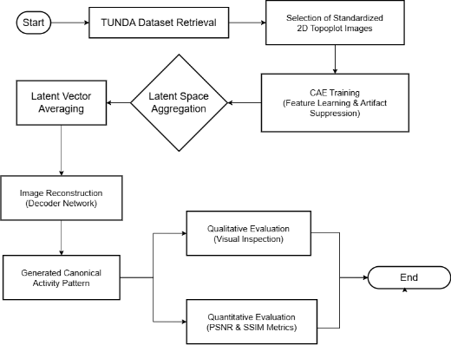
Figure 1. Research workflow
Figure 1 depicts the systematic framework used in this investigation. The first step in the workflow is data acquisition, which uses pre-computed 2D topoplot images from EEG recordings and comes from the TUNDA dataset. These images can be used directly in this input dataset without the need for resizing or other preprocessing steps because they already have a fixed size and format. In order to learn the robust spatial features while denoising those unlabeled images, a Convolutional Autoencoder (CAE) model is trained on them in core processing. A latent space aggregation strategy is used to generate a centroid representation from the averaged encoded latent vectors, which the decoder then reconstructs to produce a representative pattern for each group. Finally, a thorough evaluation that includes both qualitative visualization and quantitative metrics like PSNR and SSIM for the reconstruction fidelity is used to validate the generated canonical activity patterns.

Datasets and Distribution
This research employ a dataset collected from the Telkom University Dataverse (https://doi.org/10.34820/FK2/GW8JIV) [8]. The dataset consists of both one-dimensional and two-dimensional EEG appropriating neural responses to addiction-related terminology. The stimuli during EEG acquisition were based on the Go/No-Go Association Task (GNAT). The respondents of this dataset included recordings from twelve adolescents, categorized into normal and at-risk groups. The main focus of the study was a two-dimensional EEG analysis, of the average responses for fast and slow conditions across both categories of respondents. This approach provides a fair image of the activation patterns of each group in relation to different response speeds.
The total dataset used consisted of 812 topoplots images. Each respondent was categorized into fast and slow responses, where fast responses were less than 0.5 seconds and slow responses were more than 0.5 seconds after the stimulus appeared. The normal group had a total of 492 images, consisting of 260 fast responses and 232 slow responses. Meanwhile, the at-risk group contributed 320 images, consisting of 153 fast responses and 167 slow responses.

Autoencoder Architecture for Latent Space Aggregation
This paper uses a special computer program called a Deep Convolutional Autoencoder (CAE) to study different setups. A CAE is a kind of machine learning system that learns without needing pre-tagged examples and is built for handling huge amounts of information such as images. Unlike older autoencoders that only use simple connected layers, a CAE uses special methods to keep the original structure of the entered information [9]. A problem that is often missed with ways of doing things that use finding the average is that it does not work well to find the average of the EEG data at each single spot because of a standard level that is in the two-dimensional EEG information. Because this standard level is there, the average number at each spot is not the same, and this causes changes to the designs over the length of the time periods being looked at.
The encoding process acts as input and transforms it through a number of convolution operations. Each convolution process is calculated using the following equation:
$$h_{k}=σ(W_{k}* h_{k-1}+ b_{k})$$ | (1)
where * denotes the convolution operator $W_{k}$ is the learnable kernel matrix, $b_{k}$ is the bias term, and $h_{k-1}$ is the input feature map [10], [11]. Max-Pooling is applied to each convolution block to reduce the spatial dimension. This operation preserves the maximum value in each patch, gradually reducing the input resolution from 128 × 128 to 16 × 16 features.
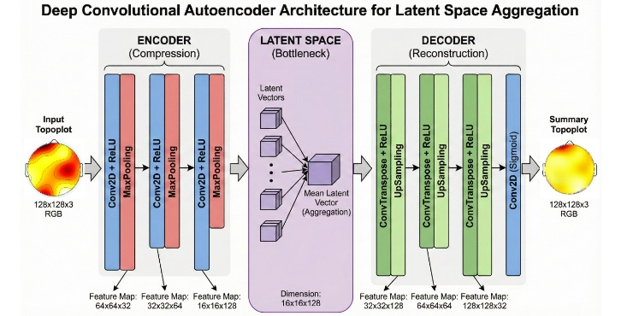
Figure 2. Simple drawing representing proposed to aggregate latent space.
The contribution of this research lies in the aggregation strategy used within the latent space, which is depicted in the central section of Figure 2. In contrast to the standard method of computing the average from multi-dimensional pixel values directly, the method suggested in this study calculates the average of condensed representational features. By averaging these latent spaces, it becomes possible to obtain more meaningful and succinct characteristics of EEG topoplot patterns, which preserve key features while also decreasing noise and redundancy. Artifacts have a greater effect on multi-dimensional pixel data. The compression phase is implemented to eliminate artifacts prior to averaging at the pixel level.
Rather than calculating the average of all single samples, the calculations are performed on groups of input points that have been classified into a specific category, as in the case of the ‘at-risk–fast’ group. Average vectors are then estimated using the following formula:
$$z_{avg}=\frac{1}{N}\sum_{i=1}^{N}{z_{i}}$$ | (2)
Where N stand for the total number of elements within the category, and zₐᵥ_{g} represents the averaged latent vector estimated for that respondent group [12], [13]. After these latent average vectors are obtained, they are decoded to produce reconstructed topoplots. This technique preserves the characteristics of the averaged latent EEG, so that the resulting visualization retains the structural patterns.

Results and Discussion
  - Normal – Fast Category Respondents
Within the Normal classification, the collection of data encompasses 492 topoplot visuals altogether. The division of these images depended on the time taken to react, which was noted while carrying out the GNAT evaluation, leading to 260 examples being placed in the 'quick' section (reaction time was less than 0.5 s) and 232 being placed in the 'delayed' section (reaction time was more than 0.5 s). Past studies seem to back up this way of sorting things, showing that really fast actions those done in only a small part of a second usually point to real or built-in thinking processes [14]. So, using GNAT is a very good way to find real brain signals when conduct research on neural responses.
A. 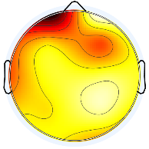B.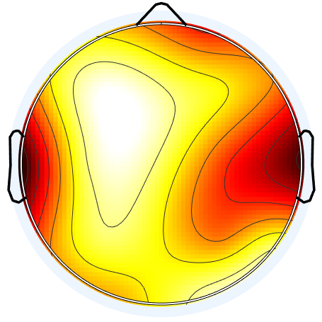C.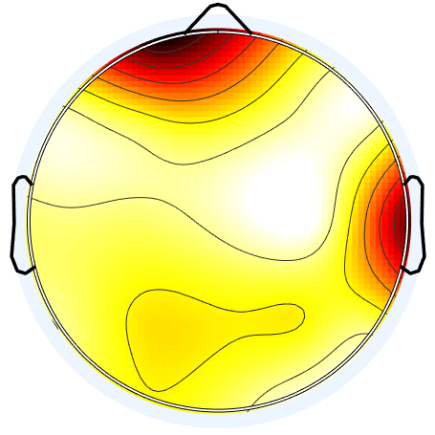
Figure 3. Examples depicting participants categorized Normal as exhibiting typical responses during quick interactions
Figure 3 presents an illustration of the raw topoplots, revealing considerable diversity in the reactions among different individuals. The brain's primary activity locations shifted unpredictably, displaying different patterns like concentrated left-frontal activity in Participant A, both-sided temporal activity arrangements in Participant B, and a more extensive distribution of frontal-temporal activity in Participant C. These examples demonstrate that unique activation high do not consistently appear in the first recordings. A noticeable shadowy imperfection furthermore constantly appears across the foundation of these images. Removing this undesirable static before the averaging procedure starts is vital to prevent it from impacting the end result.
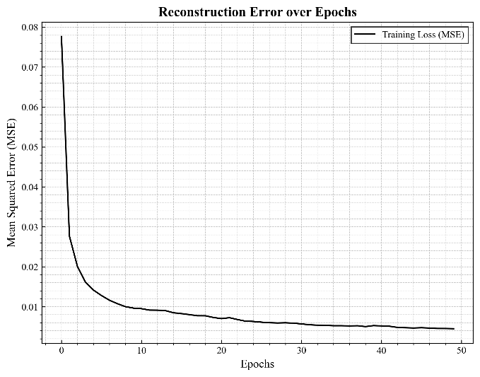
Figure 4. Reconstruction models error over epoch for normal-fast
To get a good image back, the tool that changes the image needs to put the data into a smaller, secret shape. Figure 4 shows how steady this learning is, by showing how the error gets smaller over time. After running the training process fifty times, the system came together, really bringing down the error rate to below 0.01. This state of very little error means the thinking computer is now good at picking out key brain features from useless information. So, these learned settings are used on the basic data to get rid of the unhelpful dark parts. This cleaning step works to make the active brain areas clearer in Figures 5, 6, and 7.
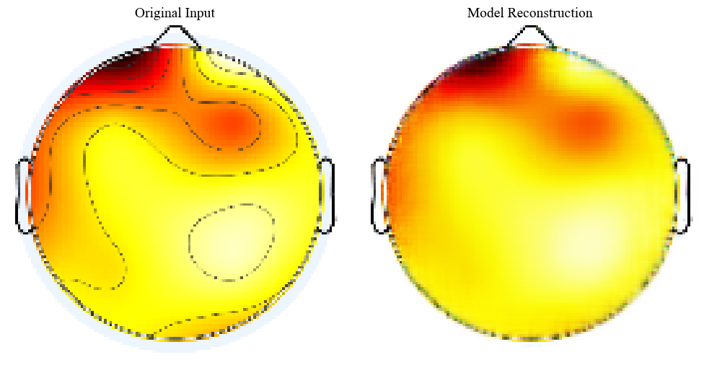
Figure 5. Reconstructed EEG topoplots output for respondent A after baseline removal
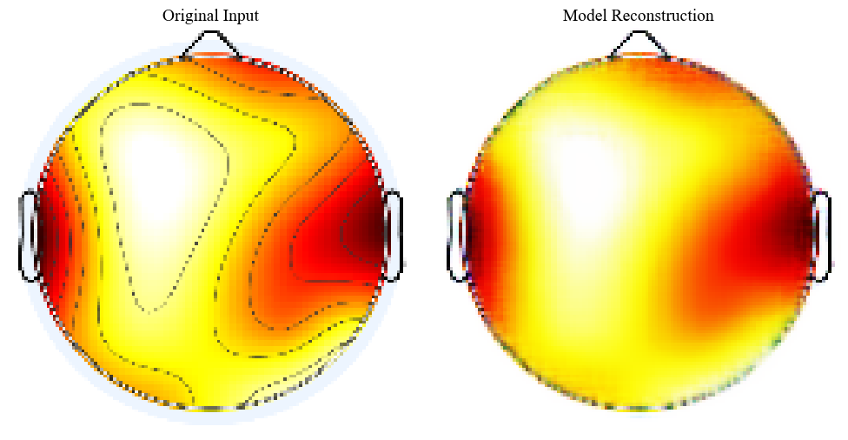
Figure 6. Reconstructed EEG topoplots output for respondent B after baseline removal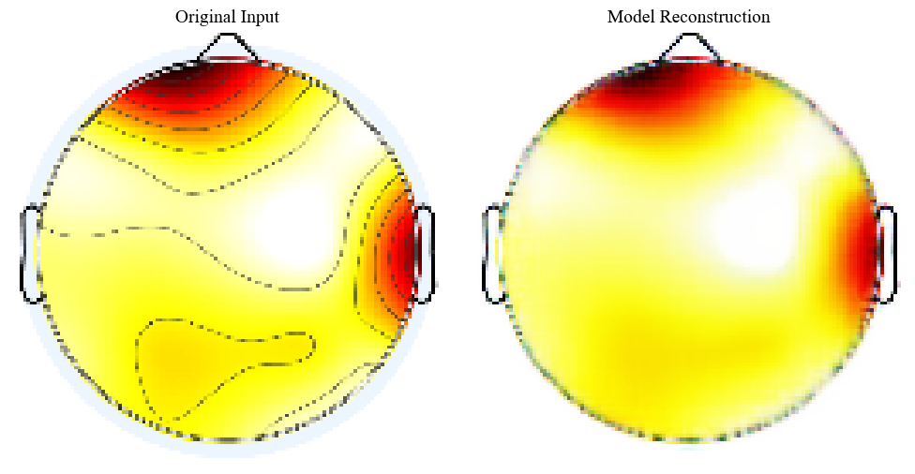
Figure 7. Reconstructed EEG topoplots output for respondent C after baseline removal.
The success of the learning method in getting rid of starting errors can be seen clearly in Figure 5 to 7. As shown in these redone images, the system does a good job of picking out areas of real brain work, clearly removing the shadowy static. After this, these neat brain maps were put through a combining step. To be exact, for the 'Fast' answer type, the combining was done using the hidden pattern form instead of the plain image parts to find similar shape traits. The finished combined result from using this way is shown in Figure 8.
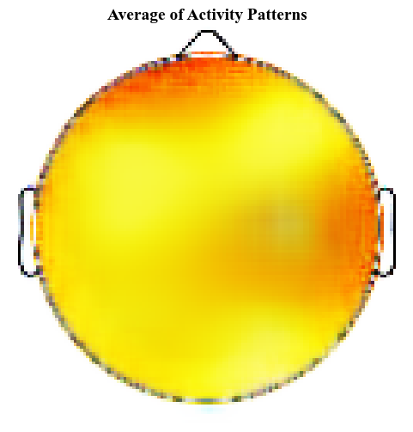
Figure 8. Typical activity patterns observed among respondents classified in the normal-fast group
Figure 8 displays the mean outcomes for the Normal-Fast group. The neural activity appears widely distributed rather than concentrated in a single area. Instead, activation spreads across the map in a gradient of yellow to orange hues. The most intense activity, shown in deep orange, is primarily located in the frontal lobe, while the temporal regions show moderate activation. This strong engagement of the frontal cortex indicates a heightened level of concentration and readiness to respond [15]. This finding aligns with existing knowledge, as frontal–temporal network interaction is a known component of cognitive response activities [16], [17].
  - Normal – Slow Category Respondents
For the Normal-Slow classification, 232 topoplots were added and the very same generative framework as in Fast group was used to maintain methodological coherence. To encompass variations within this subset, particular samples were chosen from the full dataset for comparative analysis. Showing contrasting activation patterns, these representative examples are shown in Figure 9.
D.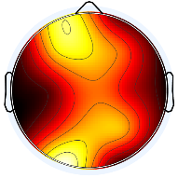E.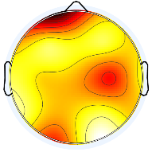F.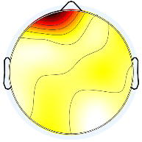
Figure 9. Illustrative cases of Normal participants demonstrating delayed responses
A closer look at the Normal-Slow dataset reveals a significant increase in signal heterogeneity. The three sample variations confirm that neural activity is much less homogeneous as respondents spend longer deciphering the addiction-related terms. The increases in processing time appear to lead to disparities in neural engagement, producing diverse activation responses. Yet, the training for the processing time condition was performed with the same autoencoder as utilized for the Normal-Fast group. The model’s performance in learning these diverse features is tracked in the training loss graph below.

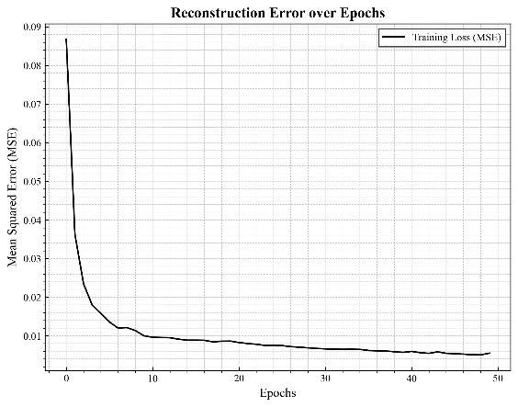
Figure 10. Reconstruction models error over epoch for normal-slow
From the training curve shown in Figure 10, the Mean Squared Error (MSE) is steadily decreasing in all epochs. The error drops below 0.01 in the 50th iteration, where the model has already converged. Interestingly, although this dataset had higher variability the loss pattern is actually consistent with the one in the Normal-Fast category. Which indicates that the autoencoder works well without being overfitted on the noisy responses of the slow responders. The generated outputs for the Normal-Slow category are shown below.
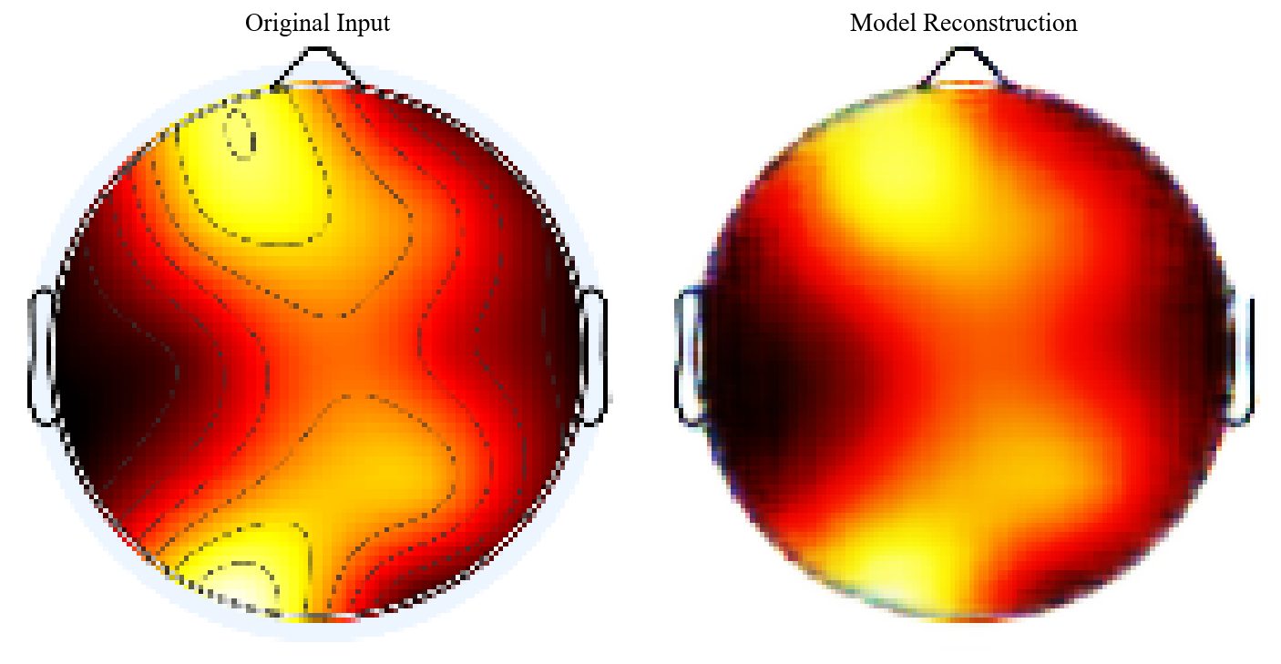
Figure 11. Reconstructed EEG topoplots output for respondent D after baseline removal

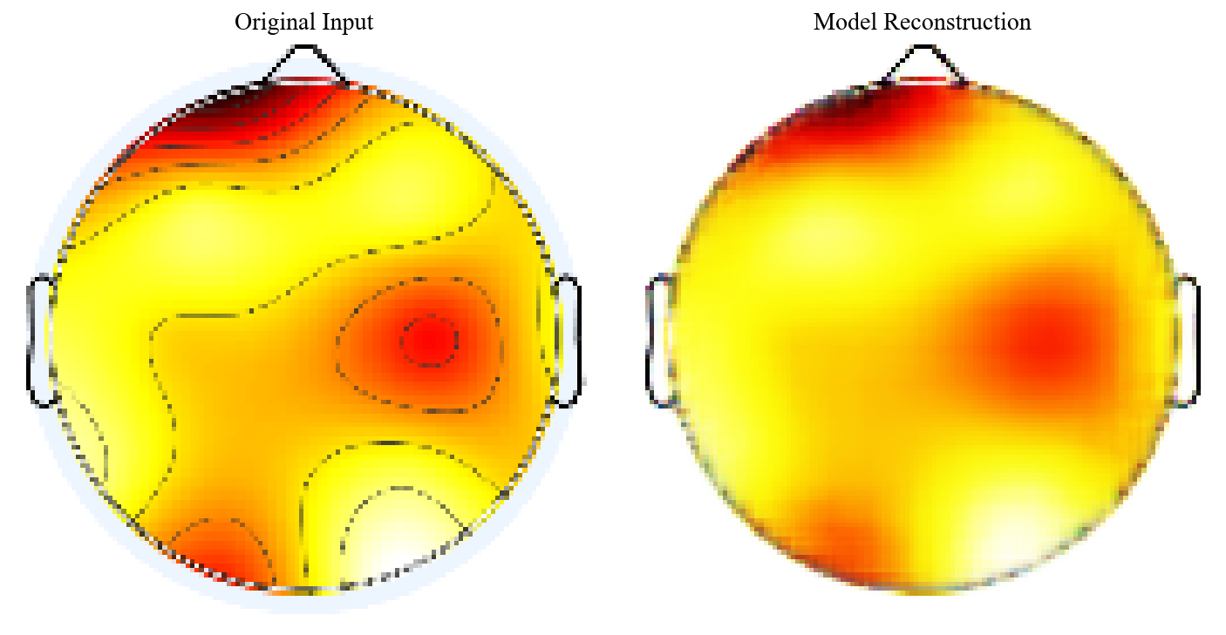
Figure 12. Reconstructed EEG topoplots output for respondent E after baseline removal

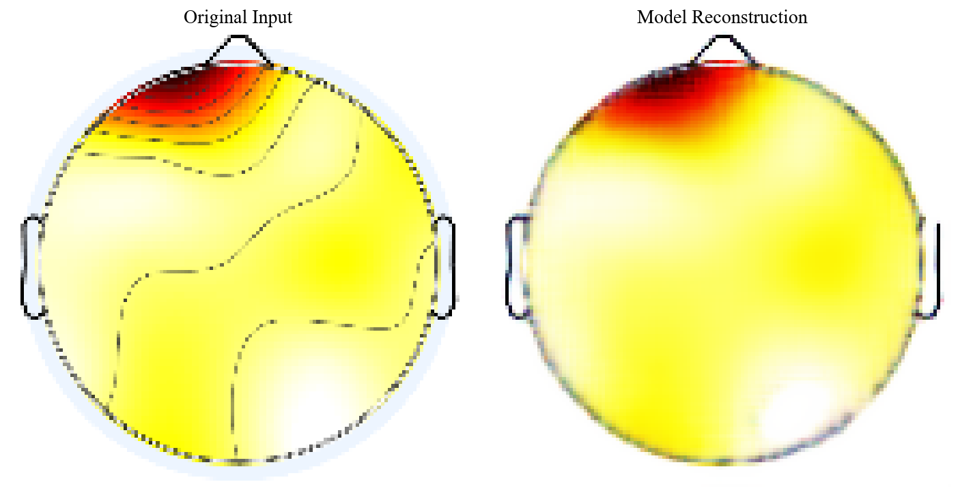
Figure 13. Reconstructed EEG topoplots output for respondent F after baseline removal

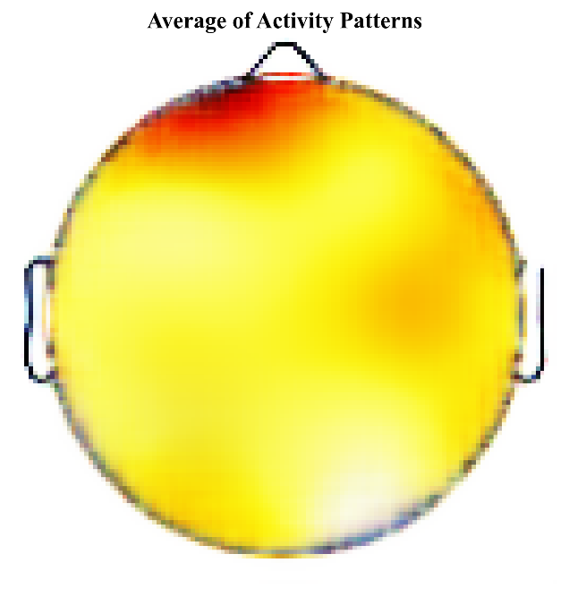
Figure 14. Mean activity patterns of respondents in the Normal-Slow category
The average topographic map in Figure 14 exhibits a highly localized pattern of activation. In contrast to the more diffused activity found within other categories, the neural activity within this category is largely restricted to the frontal lobe with no or only minimal spillover into contiguous regions. Accordingly, this pronounced frontal emphasis aligns with existing neuroscience research, which identifies the prefrontal cortex as the central region responsible for executive control, working memory, and higher-order decision-making [18]. In this instance, the occurrence of a reaction that is not immediate furnishes a sensible explanation for the focused strength, suggesting a mental processing constraint where the mind is completely engaged in deciphering the sensory input. Rather than an abrupt, spur-of-the-moment response, the substantial cognitive demand reveals that the person is deliberately employing higher-level thinking abilities to weigh up possibilities before providing a proper reply.

  - At Risk – Fast Category Respondents
Following this, the scope of the investigation is expanded to encompass the At-Risk demographic, with a particular emphasis on those individuals exhibiting quick response speeds. Within the At-Risk Fast research, the subject pool was composed of 153 images depicting EEG topoplots. Employing an identical methodology to that which was used for the Normal cohort, an assortment of unprocessed samples were compiled for an initial review by visual inspection, as depicted in Figure 15. These representative examples are essential for characterizing the baseline signal patterns, highlighting the inherent spatial variability in the data before the application of any generative processing or noise suppression techniques.
G.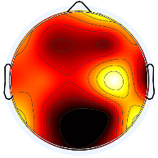H.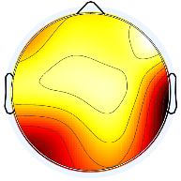I.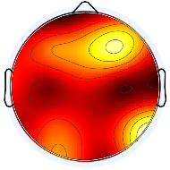
Figure 15. Examples of at-risk category in fast responses
The comparative analysis outcomes reveal that, when contrasted with the Normal group, the At-Risk Fast group's neural activity displays heightened intensity alongside reduced organization. In contrast to the focused activation observed in the datasets highlighted earlier, the At-Risk Fast sample's mean topoplots manifest a more widespread intensity arrangement, resulting in a darker coloration when juxtaposed against the Normal-Fast and Normal-Slow datasets. This broad saturation points to an elevated level of baseline neural arousal or noise. To manage this increased complexity, the data was processed through the autoencoder training pipeline. The model’s quantitative performance, particularly its capacity to capture these dense features is assessed using the loss trajectory graph shown below.
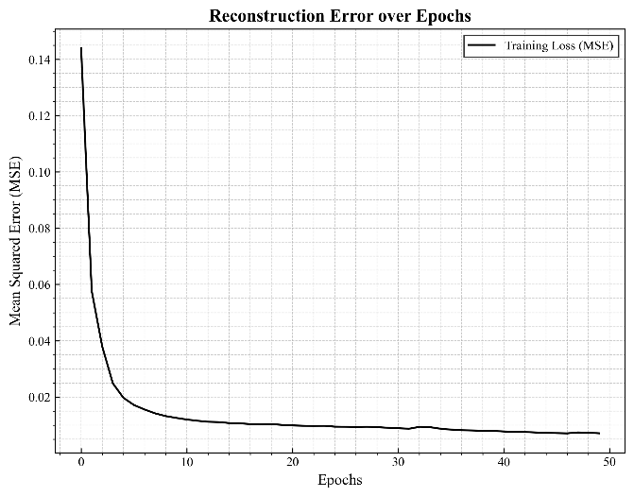
Figure 16. Reconstruction error of the model over epochs for the At-Risk Fast group
The graph shows reduction of the Mean Squared Error in Figure 16, which indicates average error while the training conducted. In the later stages of training, the error levels off, staying consistently under 0.01, which signifies successful model convergence. This result is promising, considering the complex nature of the data in question. The autoencoder successfully identifies trends in the intricate At-Risk Fast signals, instead of simply remembering unimportant noise. Following the training phase, the trained model was used to reconstruct a chosen group of three samples. This helped check how well the model works, not just by numbers but also by looking at the images it created. These images show how well the model can take out the main background problems while keeping the important signal patterns clear.
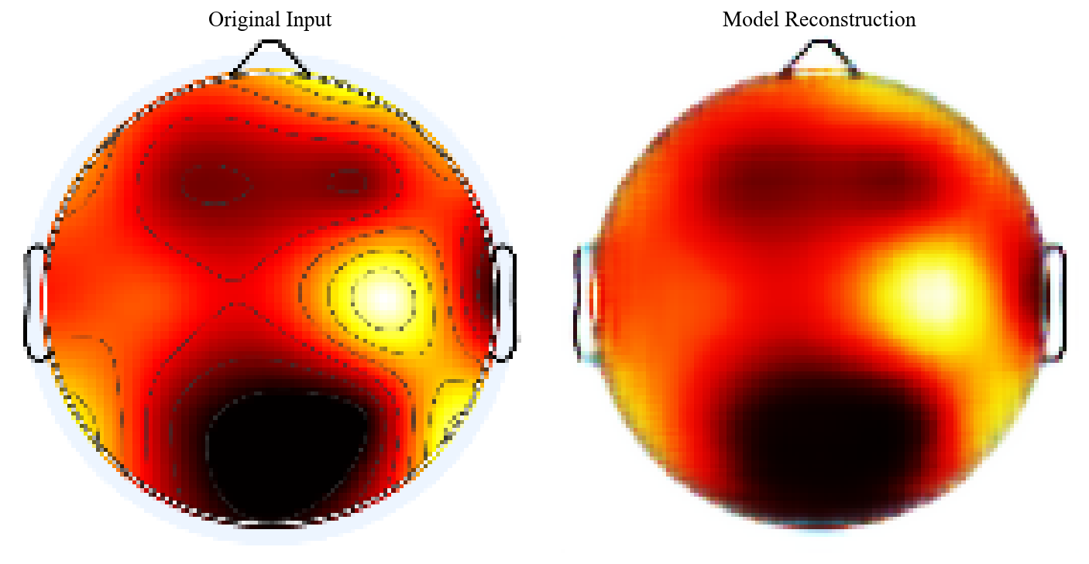
Figure 17. Reconstructed EEG topoplots for respondent G following baseline removal
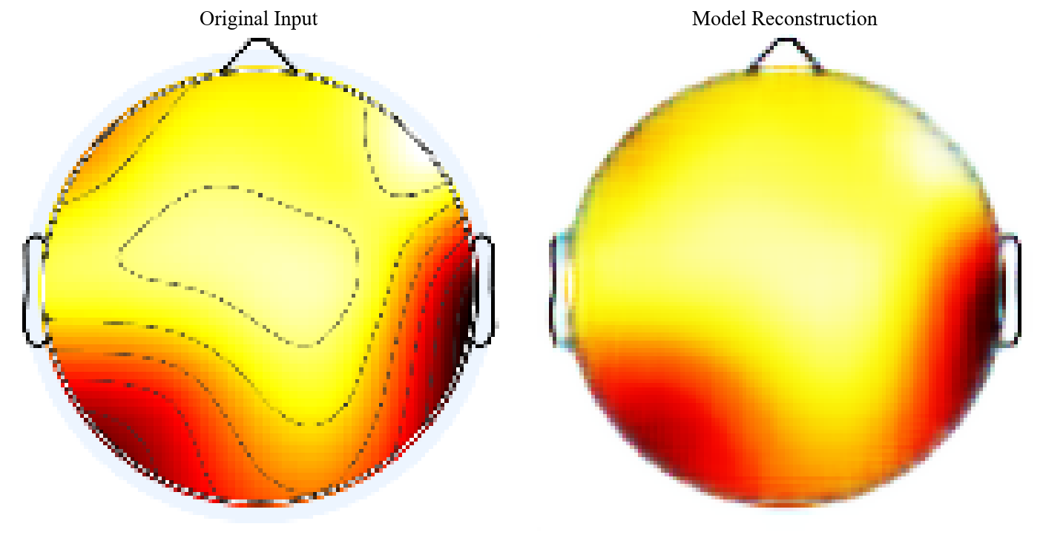
Figure 18. Reconstructed EEG topoplots for respondent H following baseline removal
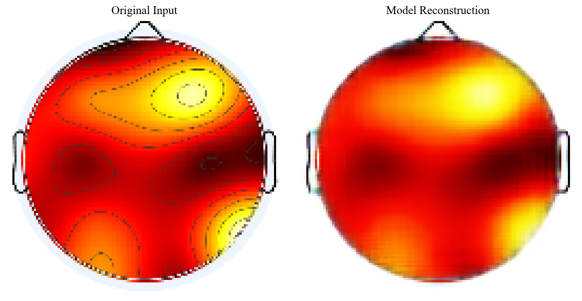
Figure 19. Reconstructed EEG topoplots for respondent I following baseline removal
Figures 17 through 19 illustrate how well the autoencoder reconstructed the images. Consistent with the favorable results observed for the Normal group, the autoencoder effectively filters out original image imperfections, allowing the resulting images to highlight regions of significant brain activity and minimize extraneous visual data. After the refinement phase, aggregation occurs by calculating average representations within the concealed area, contrasting with the use of pixel-level averaging, resulting in a visualization that is more reliable and structurally precise. The pattern synthesized and derived for the Risk-Fast group is displayed in Figure 20.

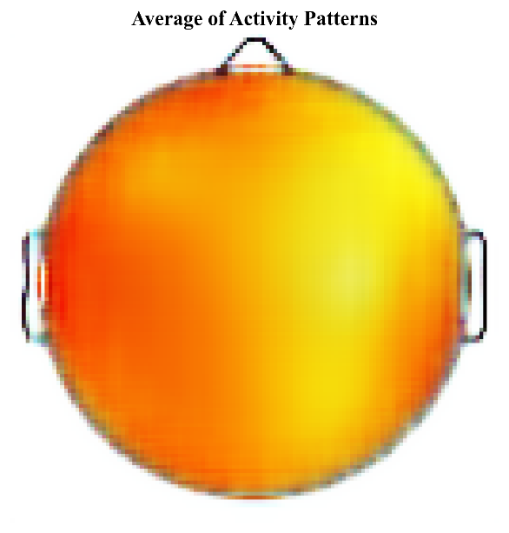
Figure 20. Mean neural activity patterns for the At-Risk Fast respondent group
The average topography shown in Figure 20 shows a special pattern in brain activity that involves many parts of the brain being active at the same time. This kind of widespread brain activity is called cortical hyper-arousal. It suggests that the brain's reaction is more about strong emotions than just thinking. These findings support a theory in neuroscience called the neural inefficiency hypothesis. This idea says that people who have trouble controlling impulses or feel more anxious need to use more parts of their brain to do the same thinking tasks as people who don't have these challenges [19]. Within the framework of this study, exposure to addiction-related terminology seems to elicit a reactive, emotionally heightened state. As a result, the fast reaction times observed in this group should not be interpreted as signs of cognitive efficiency but are more likely attributable to impulsive responding [20], [21]. This visualization provides empirical evidence that At-Risk respondents are operating under a considerably heavier cognitive and emotional burden during the assessment.

  - At Risk – Slow Category Respondents
This remaining dataset includes 167 topoplot images from participants who are at risk and have slower response times. Before starting any reconstruction, it's important to look at the raw data visually to check for irregularities, as shown in Figure 21. These examples show how unpredictable the signals are in this group, clearly showing the wild changes and high levels of noise that the model has to deal with.
J.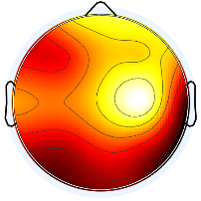K.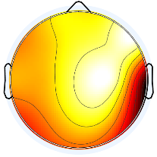L.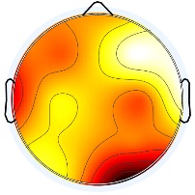
Figure 21. Illustrative cases of At-Risk participants demonstrating slower reaction times
Figure 21 shows a signal pattern that undergoes significant changes and is mostly dark. Unlike the At-Risk Fast group, which has the same bright signal everywhere, the Slow group has very different brightness in different areas. The brightness varies significantly from person to person, but the overall signal is still much darker than in the Normal group. Because brightness is not the same in all areas, it is important to train the model further to reduce noise and rebuild the underlying structure. The success of this step is demonstrated in the loss evaluation graph below.
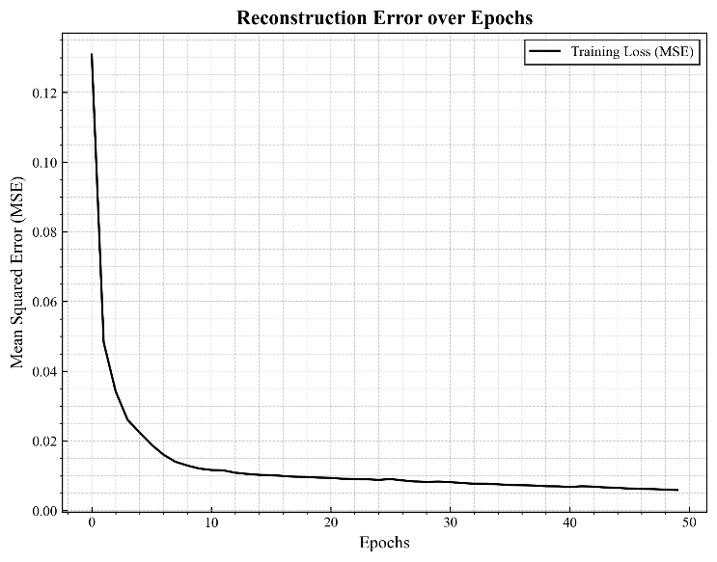
Figure 22. Reconstruction models error over epoch for At Risk-Slow
The training results show that the loss stayed just above 0.01 (MSE > 0.01), which stopped the model from achieving the deeper improvement seen in other groups. This small increase in error suggests that the data has some natural differences and may be related to the unstable brain activity when people who are slow in responding to risk-related tasks take more time to process the information. Even with this difference in performance, the results in Figure 22 show that the model is still very effective. It efficiently removes baseline artifacts, allowing the main activity zones to stand out clearly from the background noise. With the signal refined, then averaged the topoplots to visualize the group’s shared areas of cognitive focus. The resulting spatial patterns are presented in Figures 23 through 25.
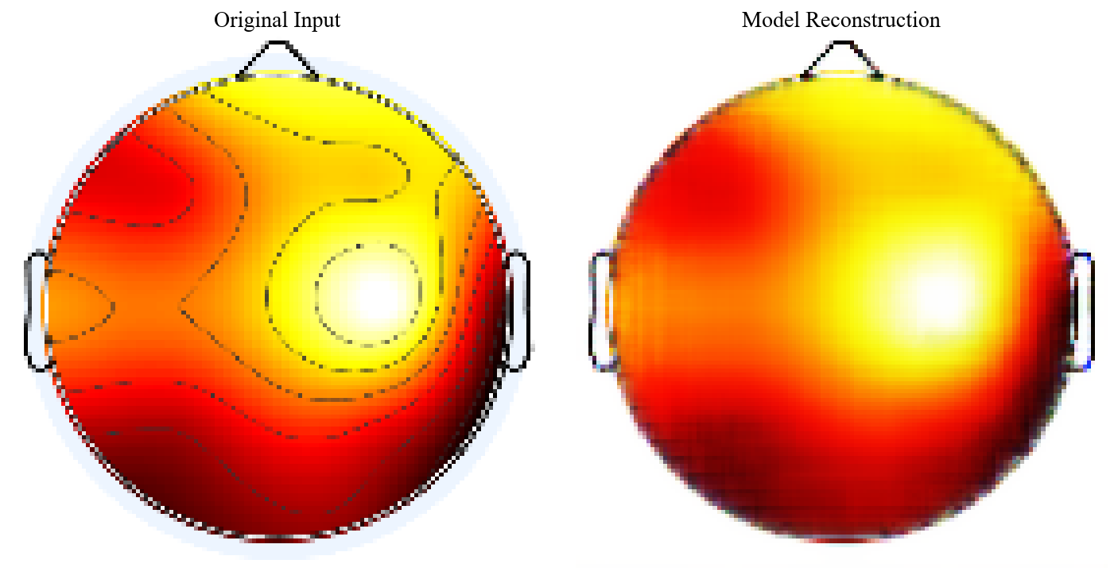
Figure 23. Reconstructed EEG topoplots output for respondent J after baseline removal
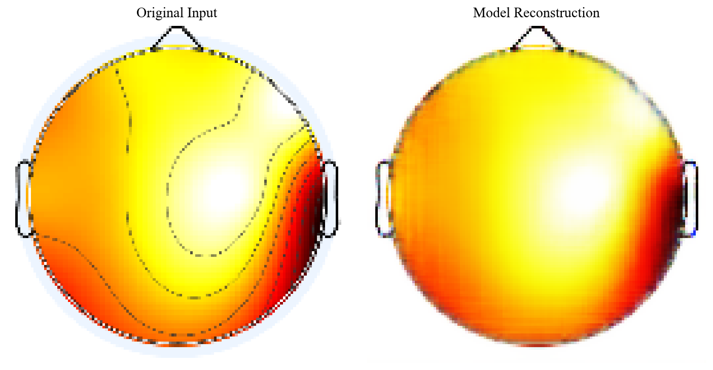
Figure 24. Reconstructed EEG topoplots output for respondent K after baseline removal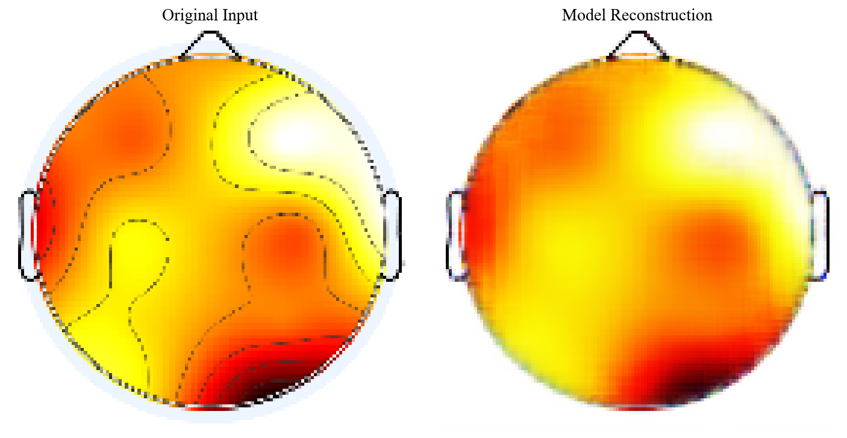
Figure 25. Reconstructed EEG topoplots output for respondent L after baseline removal.
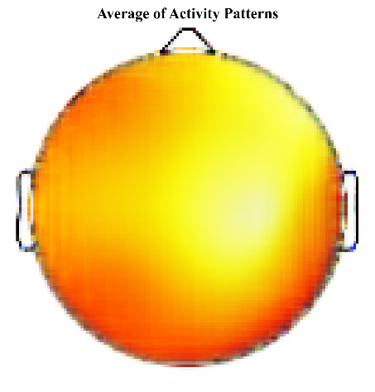
Figure 26. Average of activity patterns in at-risk slow category respondent
The average topography shows a clear imbalance in brain activity. Most activity is focused in the back part of the brain, especially in the Occipital and Temporal lobes, while the Frontal area has very little activity. This pattern supports the ‘Attentional Bias’ idea that is often talked about in studies on addiction. The higher activity in the Occipital lobe suggests people are looking at or focusing on images related to addiction, and the activity in the Temporal lobe shows that they are automatically remembering related memories or meanings connected to drug use [22]. Because of this, the slower reaction times show that there's a problem with the brain's ability to control actions. The brain is focusing too much on seeing things and recalling memories, which creates a block that stops the frontal lobe from making quick decisions. Also, this lower activity in the frontal area matches research that shows using narcotics can damage how well the prefrontal cortex works [23].

  - At Risk – Slow Category Respondents
The evaluation framework includes the Peak Signal-to-Noise Ratio (PSNR) and the Structural Similarity Index Measure (SSIM) to support the visual analysis and provide a reliable indicator of model performance. SSIM is a crucial perceptual metric that measures how well the generated summaries retain the structural characteristics of the original EEG topoplots [24]. Meanwhile, PSNR provides an estimation of the reconstruction error by calculating the ratio between the maximum signal power and the noise introduced during the compression-decompression process [24]. Together, these metrics validate the model's capability to minimize information loss while maintaining the spatial characteristics essential for accurate neurological interpretation.

Table 1. Comparative result using SSIM and PSNR
Category | Samples | SSIM | PSNR
Normal-Fast | 260 | 0.73 | 23.20
Normal- Slow | 232 | 0.78 | 23.63
At-Risk Fast | 153 | 0.68 | 20.62
At-Risk Slow | 167 | 0.72 | 22.01

SSIM and PSNR measurements are used to compare how well the four test scenarios replicated the data, as shown in Table 1. The data indicates that the Normal and At-Risk categories differ clearly and consistently. The designs in the Normal-Slow category are the most dependable and structurally sound because they were the best at accurately reproducing the data (SSIM: 0.78; PSNR: 23.63 dB). However, the At-Risk categories did not replicate the data as well in either frequency range; the least accurate category was At-Risk Fast (SSIM: 0.68; PSNR: 20.62 dB).
These numbers suggest that the brain activity designs in the At-Risk category are more complicated and inconsistent. The Deep Autoencoder, which learns the standard parts of the data, had a harder time recreating the At-Risk topoplots because they were different from the reliable designs seen in the Normal category. This drop in SSIM/PSNR for the At-Risk category gives hard evidence that being in a diseased or at-risk state causes problems with how the brain works, which shows up as more spatial randomness in the EEG signals.

  - General Discussion
A more focused comparison of both the Normal-Fast and At-Risk Fast groups reveals that identical RTs can stem from very dissimilar processes. Even though both reacted very quickly (less than 0.5 seconds), their combined topoplots indicate that both groups used very different cognitive processes. A similar pattern could be observed with regard to the Normal-Fast group: their neural processes seemed to be pretty much concentrated in the frontal and temporal areas of their brains. This speaks well for neural efficiency-wherein efficient pathways, indeed, result in very fast responses.
The At-Risk Fast group exhibited widespread and increased activation in the cortex compared to the other two groups. This condition is indicative of hyper-arousal. The current results support the neural inefficiency hypothesis, which has been proposed in the literature on addiction and suggests that a significant amount of brain activity is needed to complete very basic tasks, rather than cognitive efficiency. As a result, the fast response in at-risk teenagers should not be regarded as the sign of cognitive preparedness but reflected impulsiveness driven by addiction cues [22].
The slow-response criteria also demonstrated clear differences. The localized activation in the prefrontal region in the Normal-Slow group corresponds with a more deliberative style of decision-making. On the other hand, the At-Risk Slow group demonstrated lower levels of frontal activation with a clear weighting towards posterior areas, particularly occipital and temporal regions. This suggests that biased versus controlled attention is responsible for the slow responses in at-risk individuals. Reduced frontal activation indicates poor inhibitory control, whereas increased occipital-temporal activity indicates increased visual attention and memory retrieval linked to addiction cues. These findings are consistent with the dual-process model of addiction, in which an overactive impulsive system dominates a weakened reflective system.
These observations receive additional quantitative support through SSIM and PSNR analysis, allowing for the evaluation of reconstructed EEG signal quality. The reduced fidelity in At-Risk group reconstructions (SSIM: 0.68-0.72) compared to those in Normal groups (SSIM: 0.73-0.78) cannot be considered a weakness of the model. Rather, it is representative of elevated amounts of signal entropy and at-risk spatial irregularity in at-risk EEG patterns. Since the autoencoder model is trained to exploit stable and meaningful patterns, differential difficulties in At-Risk group reconstructions indicating elevated levels of stochastic noise and reduced levels of neural synchrony will be present. Here, reduced SSIM and PSNR values provide an objective means for indicating at-risk levels of neural organization, supporting the capability of deep autoencoders not only for visualization means, but for sensitive measurement tools for at-risk levels of neural signal in addiction study.

Conclusion
Based on the test results, each group showed that response time has a different meaning for each respondent. According to the study, fast reactions typically occur when alert and impulsive responses are present. Meanwhile, slow reactions tend to be more thoughtful and less focused. From a scientific standpoint, using the Autoencoder approach was a major improvement in studying patterns of brain activity. Instead of older methods that might make the signal worse, the Autoencoder uses secret patterns in the data to tell the difference between real brain activity and unimportant noise [25].
The CAE method is efficient for masking baseline noise in EEG topography. This model can learn the baseline noise pattern and remove it, making the approach to analyzing topoplots easier and clearer [26]. In that case, it becomes a successful endeavour to affirm that the Autoencoder is a formidable tool in the area of noise reduction as well as a strong system in the area of image processing, being able to detect a complex neural activity that usually lies hidden in the unprocessed signals of the EEG.
The disparities in outcomes, especially in at-risk populations, present encouraging opportunities for additional research. These findings imply that each person's brain responds to addiction-related triggers in a unique way. To determine the reasons behind this variation, more investigation is required. Better models that visually represent topoplots can be developed through the use of techniques like Generative Adversarial Networks (GANs) and Variational Autoencoders (VAEs). On top of that, adding Explainable AI (XAI) strategies is a really important step forward because it lets scientists understand why the model is focusing on certain parts of the brain's outer layer. This helps bridge the gap between deep learning and useful clinical findings in the area of addiction psychiatry. Longitudinal studies could also be employed to track how these topographical patterns evolve over time, offering potential biomarkers for monitoring rehabilitation progress.

Acknowledgment
This research was conducted with funding from a competitive postgraduate research grant v.

References
[1] G. Placidi, L. Cinque, and M. Polsinelli, “Convolutional Neural Networks for Automatic Detection of Artifacts from Independent Components Represented in Scalp Topographies of EEG Signals,” Sep. 2020, doi: 10.1016/j.compbiomed.2021.104347.
[2] V. Janiukstyte et al., “Normative brain mapping using scalp EEG and potential clinical application,” Sci. Rep., vol. 13, no. 1, Dec. 2023, doi: 10.1038/s41598-023-39700-7.
[3] I. Wijayanto et al., “Unlocking Early Detection and Intervention Potential: Analyzing Visual Evoked Potentials in Adolescents/ Teenagers with Narcotics Abuse Tendencies from the TelUnisba Neuropsychology Electroencephalograph Dataset,” J. Electron. Electromed. Eng. Med. Informatics, vol. 6, no. 4, pp. 445–458, Oct. 2024, doi: 10.35882/jeeemi.v6i4.476.
[4] R. A. Clark, N. Nikolova, W. J. McGeown, and M. Macdonald, “Eigenvector alignment: Assessing functional network changes in amnestic mild cognitive impairment and Alzheimer’s disease,” PLoS One, vol. 15, no. 8 August, Aug. 2020, doi: 10.1371/journal.pone.0231294.
[5] T. Wen and Z. Zhang, “Deep Convolution Neural Network and Autoencoders-Based Unsupervised Feature Learning of EEG Signals,” IEEE Access, vol. 6, pp. 25399–25410, May 2018, doi: 10.1109/ACCESS.2018.2833746.
[6] M. Q. Pérez, S. L. Bernal, E. H. Prat, L. M. Del Campo, L. F. Maimó, and A. H. Celdrán, “EEG channel reconstruction using convolutional neural networks in limited BCIs: A proposed method for neuromarketing applications,” Appl. Soft Comput., vol. 181, Sep. 2025, doi: 10.1016/j.asoc.2025.113455.
[7] T. Hoffmann, “Latent space approaches to aggregate network data,” Mar. 2023, [Online]. Available: http://arxiv.org/abs/2303.08338
[8] I. Wijayanto, “TelUnisba Neuropsychology EEG Dataset (TUNDA),” 2024, Telkom University Dataverse. doi: 10.34820/FK2/GW8JIV.
[9] J. Masci, U. Meier, D. Cireşan, and J. Schmidhuber, “Stacked convolutional auto-encoders for hierarchical feature extraction,” Lect. Notes Comput. Sci. (including Subser. Lect. Notes Artif. Intell. Lect. Notes Bioinformatics), vol. 6791 LNCS, no. PART 1, pp. 52–59, 2011, doi: 10.1007/978-3-642-21735-7_7.
[10] R. Yamashita, M. Nishio, R. K. G. Do, and K. Togashi, “Convolutional neural networks: an overview and application in radiology,” Insights Imaging, vol. 9, no. 4, pp. 611–629, 2018, doi: 10.1007/s13244-018-0639-9.
[11] S. Albawi, T. A. M. Mohammed, and S. Alzawi, “Understanding of a Convolutional Neural Network,” Icet2017, pp. 1–6, 2017.
[12] Y. Bengio, A. Courville, and P. Vincent, “Representation learning: A review and new perspectives,” IEEE Trans. Pattern Anal. Mach. Intell., vol. 35, no. 8, pp. 1798–1828, 2013, doi: 10.1109/TPAMI.2013.50.
[13] D. Berthelot, I. Goodfellow, C. Raffel, and A. Roy, “Understanding and improving interpolation in autoencoders via an adversarial regularizer,” 7th Int. Conf. Learn. Represent. ICLR 2019, 2019.
[14] E. M. Templeton, L. J. Chang, E. A. Reynolds, and M. D. Cone, “Fast response times signal social connection in conversation,” vol. 119, no. 4, 2022, doi: 10.1073/pnas.2116915119/-/DCSupplemental.Published.
[15] T. Emsawas, T. Kimura, S. Ogura, H. Morita, and E. Abdullajon, “Identifying english proficiency by frontal theta activity during english learning,” Discov. Educ., 2025, doi: 10.1007/s44217-025-00517-3.
[16] A. Valentin, R. Selway, G. Alarco, M. E. Lacruz, and J. J. Garcı, “Frontal and temporal functional connections of the living human brain,” vol. 26, no. March, pp. 1357–1370, 2007, doi: 10.1111/j.1460-9568.2007.05730.x.
[17] M. Kotas, M. Piela, and S. Contreras-Ortiz, “Modified Spatio-Temporal Matched Filtering for Brain Responses Classification,” IEEE Trans. Human-Machine Syst., vol. 52, pp. 1–10, Jan. 2022, doi: 10.1109/THMS.2022.3168421.
[18] X. Liang, F. Xiao, Y. Lei, H. Li, and Q. Chen, “N400/frontal negativity reveals the controlled processes of taxonomic and thematic relationships in semantic priming for artifacts,” Psychophysiology, vol. 57, no. 2, Feb. 2020, doi: 10.1111/psyp.13486.
[19] A. C. Neubauer and A. Fink, “Neuroscience and Biobehavioral Reviews Intelligence and neural efficiency,” vol. 33, pp. 1004–1023, 2009, doi: 10.1016/j.neubiorev.2009.04.001.
[20] J. Zhang, L. Yang, Y. Zhang, H. Su, Y. Zhang, and Y. Yang, “Updating Emotional Stimuli in Heroin Abstainers’ Working Memory: An Event-Related Potential Investigation,” Subst. Use Misuse, vol. 56, no. 6, pp. 801–807, 2021, doi: 10.1080/10826084.2021.1899223.
[21] G. F. Koob and N. D. Volkow, “Neurobiology of addiction : a neurocircuitry analysis,” The Lancet Psychiatry, vol. 3, no. 8, pp. 760–773, 2016, doi: 10.1016/S2215-0366(16)00104-8.
[22] Y. Yalachkov, J. Kaiser, and M. J. Naumer, “Sensory and motor aspects of addiction,” vol. 207, pp. 215–222, 2010, doi: 10.1016/j.bbr.2009.09.015.
[23] A. O. Ceceli and C. W. Bradberry, “The neurobiology of drug addiction : cross-species insights into the dysfunction and recovery of the prefrontal cortex,” no. August, 2021, doi: 10.1038/s41386-021-01153-9.
[24] A. Horé and D. Ziou, “Image Quality Metrics: PSNR vs. SSIM,” in 2010 20th International Conference on Pattern Recognition, 2010, pp. 2366–2369. doi: 10.1109/ICPR.2010.579.
[25] T. Zhao et al., “NeuroImage VAEEG : Variational auto-encoder for extracting EEG representation,” Neuroimage, vol. 304, no. July, p. 120946, 2024, doi: 10.1016/j.neuroimage.2024.120946.
[26] M. Y. Sikkandar et al., “Optimization Driven Variational Autoencoder GAN for Artifact Reduction in EEG Signals for Improved Neurological Disorder and Disability Assessment,” no. 1, pp. 10–14, 2025, doi: 10.2478/msr-2025-0002.

